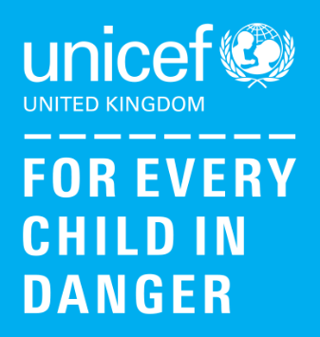

As conflict continues to escalate in Ukraine, millions of children and their families are in danger.

How UNICEF is helping children in Ukraine:
We have been working tirelessly to keep children safe since this conflict began eight years ago and we are determined to remain in Ukraine to reach the most vulnerable children and families.
- We are helping to provide families with access to clean water and healthy food.
- We are delivering lifesaving supplies to support families who have been forced to flee and are working closely with local health facilities to ensure they have the vital supplies needed.
- We are helping to make sure that child protection services continue.
- We are working with our partners and the UNHCR to assess the refugee situation across neighbouring countries.
- In neighbouring countries, we are delivering Blue Dot safe spaces with our partners, which will provide care and support, information to families seeking refuge, psychosocial support, water and sanitation supplies, safe spaces for mothers and children, protection for unaccompanied and separated children and more.
At Old Church Nursery, we will be holding a Wear Something Blue or Yellow on Friday 25th March to raise money and help children and their families.
Children can donate £1.00 and staff will be holding a loose change bucket at the end of the day throughout the week.

