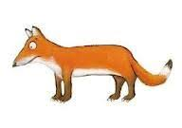
Fox’s Sandwiches

You will need:
1 slice of bread
Cream cheese
1 slice of cheese
2 slices of cucumber
Either tomatoes/olives/raisins for the eyes
Thin strips of either chives, cucumber, lettuce, celery, peppers, coriander stalks for the whiskers
A circle cutter
A sharp knife
A butter knife

Method:
1, Press your circle cutter into the bread and take off the round piece.
2, Spread the round piece of bread with cream cheese using a butter knife.
3, Press your circle cutter into the slice of cheese and take out the round piece.
4, Now cut the round piece of cheese into the shape of a fox’s face. Cut away a leaf shaped section from either side with your cutter.
5, You will now have three pieces of cheese: one big, and two small. Carefully place the big piece of cheese on top of the cream cheese.
6, Cut one of the small pieces of cheese in half.
7, Place the cheese halves at the top of the fox’s face to make his ears.
8, Use a sharp knife to cut the two slices of cucumber.
9, Use a knife to halve your chives, olives, tomatoes etc. for the eyes
10, Now decorate your fox! Two slices of cucumber and two halved olives, tomatoes etc. or add raisins for the eyes, chives or thinly sliced cucumber, lettuce, coriander stalk, celery etc. for the whiskers and another halved olive, tomato or raisin for the fox’s nose.
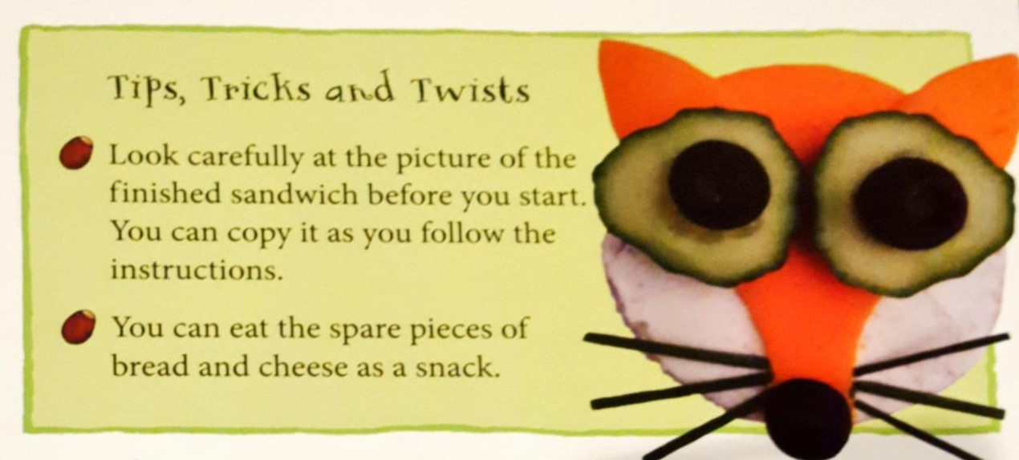
Enjoy!
Please email photos of your sandwiches to your child’s keyworker for their special book.

