Number Rhymes

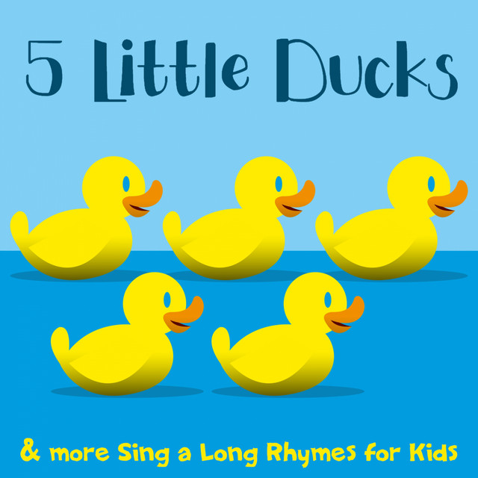
Five little ducks went swimming one day,
Over the hill and far away.
Mummy duck said, “Quack, quack, quack, quack”
And only four little ducks came back!
(continue until the final verse)
One little duck went swimming one day,
Over the hill and far away.
Mummy duck said, “Quack, quack, quack, quack”
And all her five little ducks came back!
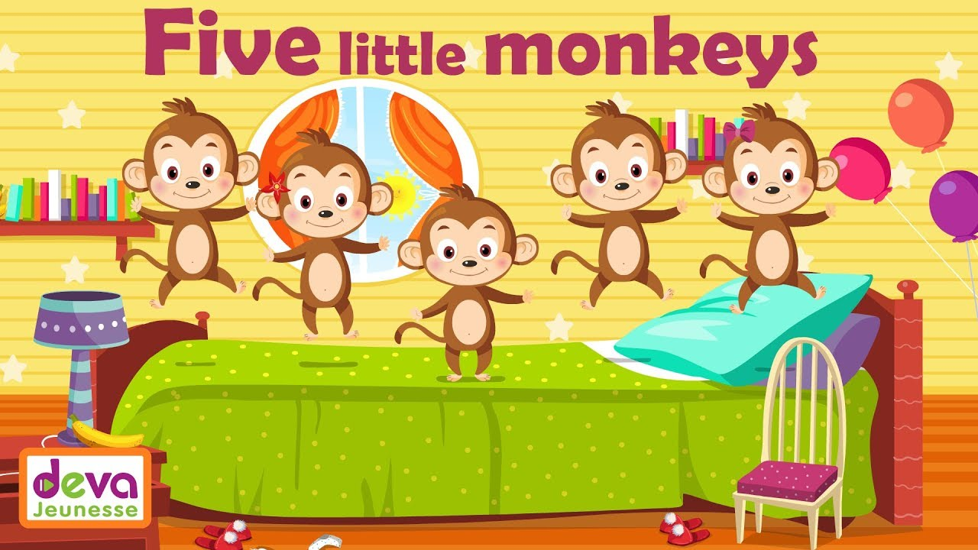

Five little monkeys jumping on the bed
One fell off and bump his head
Daddy called the doctor
And the doctor said
No more Monkeys jumping on the bed
(continue until the final verse)
One little monkey jumping on the bed
He fell off and bump his head
Daddy called the doctor
And the doctor said
No more Monkey jumping on the bed

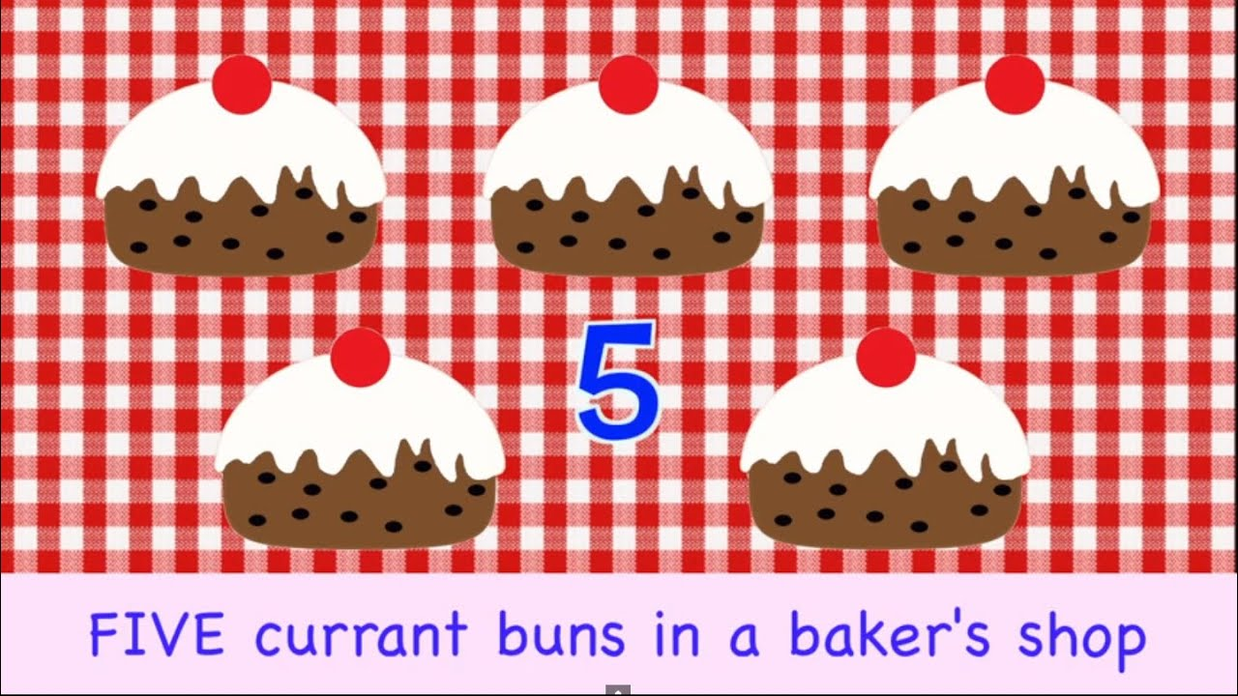
Five currant buns in a baker's shop
Big and round with a cherry on the top.
Along came (choose a name) with a penny one day
Bought a currant bun and took it away.
(continue until the final verse)
One currant bun in a baker's shop
Round and fat with sugar on the top
Along came (choose a name) with a penny one day
Bought the currant bun and took it away
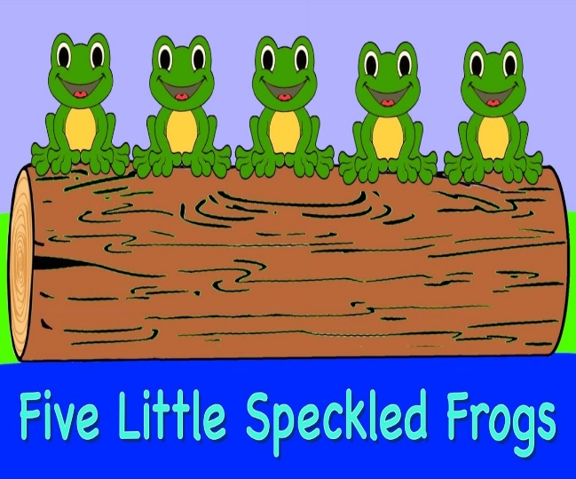
Five little speckled frogs
Sat on a speckled log
Eating some most delicious grubs - yum, yum
One jumped into the pool
Where it was nice and cool
Then there are four green speckled frogs - glub, glub.
(continue until the final verse)
One little speckled frog
Sat on a speckled log
Eating some most delicious grubs - yum, yum
One jumped into the pool
Where it was nice and cool
Then there are no green speckled frogs - glub, glub.

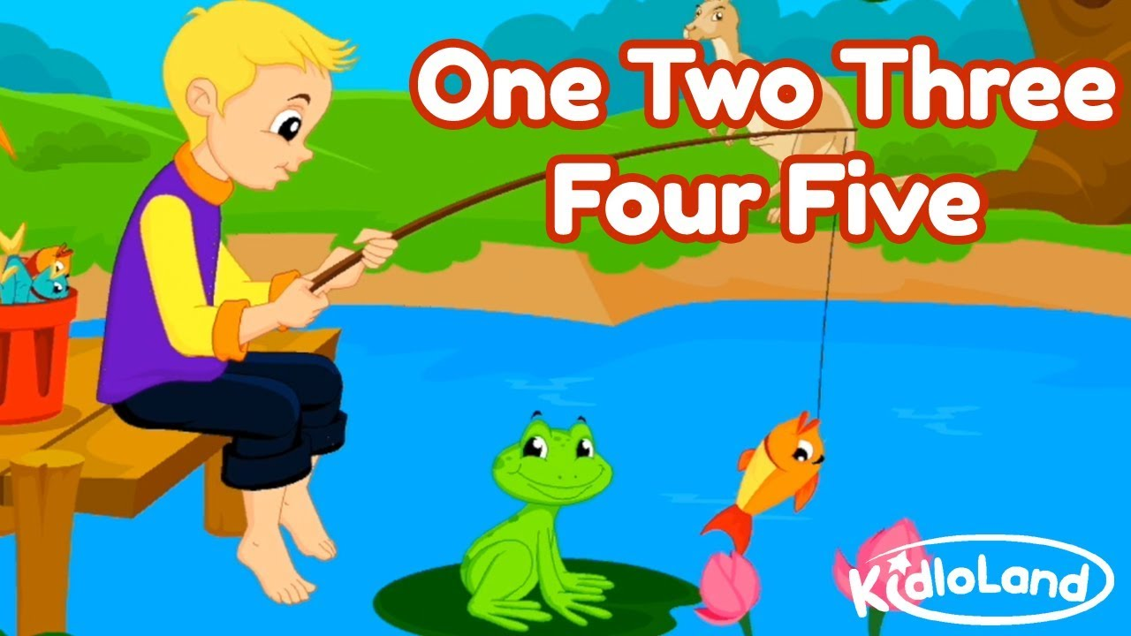
One, two, three, four, five,
Once I caught a fish alive,
six, seven, eight, nine, ten,
Then I let it go again.
Why did you let it go?
Because it bit my finger so.
Which finger did it bite?
This little finger on the right.

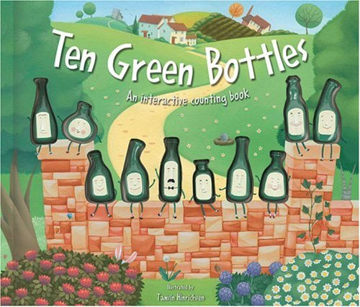
Ten green bottles sitting on the wall,
Ten green bottles sitting on the wall,
And if one green bottle should accidentally fall,
There will be nine green bottles sitting on the wall.
(continue until the final verse)
One green bottle sitting on the wall,
One green bottle sitting on the wall,
And if this green bottle should accidentally fall,
There will no green bottles sitting on the wall.

Below is a link to a website with more number rhymes for you to sing at home.
https://www.nurseryrhymes.org/numbers.html

