Cooked Playdough Recipe
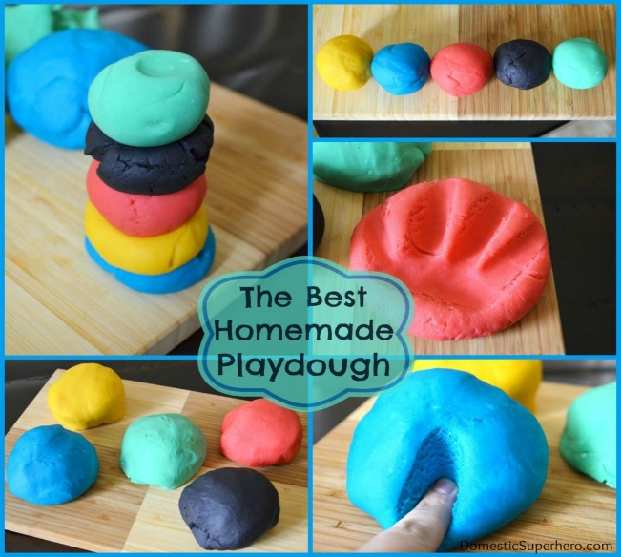
Ingredients
- 1 cup flour
- 1 cup water
- 2 tsp cream of tartar
- 1/3 cup salt
- 1 Tbsp vegetable oil
- Food colouring

Instructions
- Mix all the ingredients together, except for the food colouring, in a medium saucepan.
- Cook over low/medium heat, stirring. Once it begins to thicken, add the food colouring.
- Continue stirring until the mixture is much thicker and begins to gather around the spoon.
- Once the dough is no longer wet, remove from the pan and place onto a plate.
- After cooling (30 minutes) knead playdough for a few seconds.
PLAY!
- Store in an airtight container in the fridge!

Recipe Notes
The above will make you ONE large ball of playdough. You can repeat the recipe for however many colours you would like to make (so if you want 6 big balls, know that you will need 6 times the ingredients listed above, but you need to make them separately)

