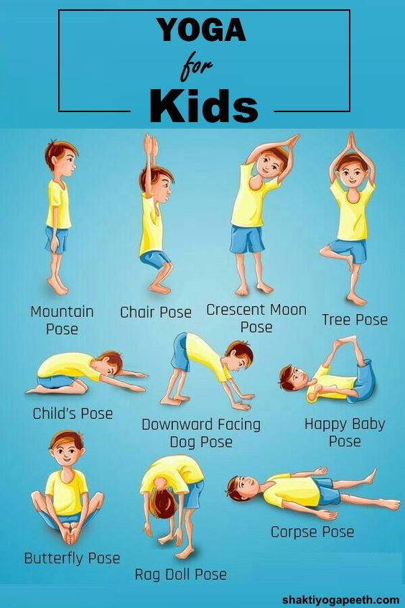

The children have thoroughly enjoyed doing this yoga routine each day. They hold each pose for a minute or so; accompanied to the music in the YouTube video that we have linked below. We are sure that you will agree that they have become very good at the routine indeed!
https://www.youtube.com/watch?v=6GVgncA9oiw

